 | 26.10.15 Editors - Properties Editor - Particle Properties Tab - Hair - Hair Shape panel
Table of content
Hair Shape panel 1
Strand Shape 1
Diameter Root 1
Tip 1
Diameter Scale 1
Close Tip 1

Hair Shape panel
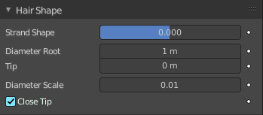
These settings control the shape of hair curves for rendering.

Strand Shape
A shape parameter that controls the transition in thickness between the root and tip. Negative values make the primitive rounded more towards the top, the value of zero makes the primitive linear, and positive values make the primitive rounded more towards the bottom.

Diameter Root
Multiplier of the hair width at the root.

Tip
Multiplier of the hair width at the tip.

Diameter Scale
Multiplier for the Root and Tip values. This can be used to change the thickness of the hair.

Close Tip
Sets the thickness at the tip to zero, even when using a non-zero tip multiplier.

